- NETWORK TROUBLESHOOTING COMMANDS ASSIGNMENT
Q1. Find IPv4 Address and Default Gateway Using ipconfig
Steps:
- Press Windows + R, type cmd, and press Enter.
- In Command Prompt, type the command shown below and press Enter.
- Look under the active Wi-Fi or Ethernet adapter.
- Find the IPv4 Address and Default Gateway values.
- Take a screenshot that clearly shows the command and both values.
ipconfig
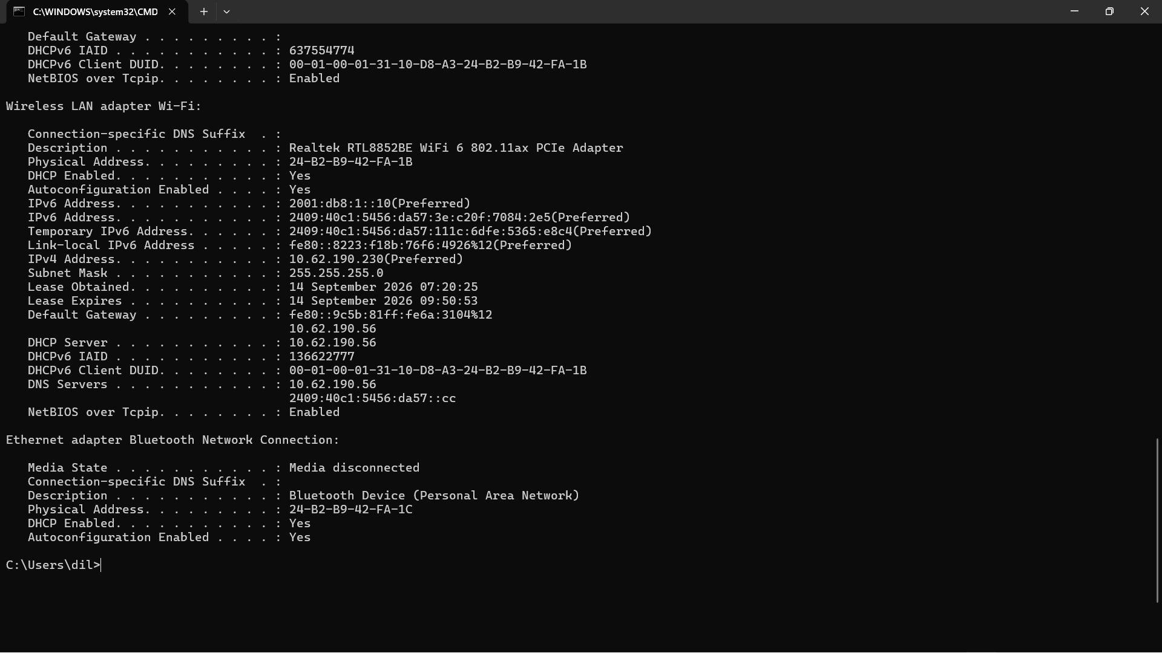
Q2. Test Connectivity to Google Using ping
Steps:
- Open Command Prompt.
- Type the command below and press Enter.
- Wait until all ping requests finish.
- Look at the Ping statistics section. Under Approximate round trip times, note the Average value.
- Take a screenshot showing the ping replies and statistics.
ping www.google.com
Explanation: Ping checks whether the destination can be reached over the network and reports round-trip response times.
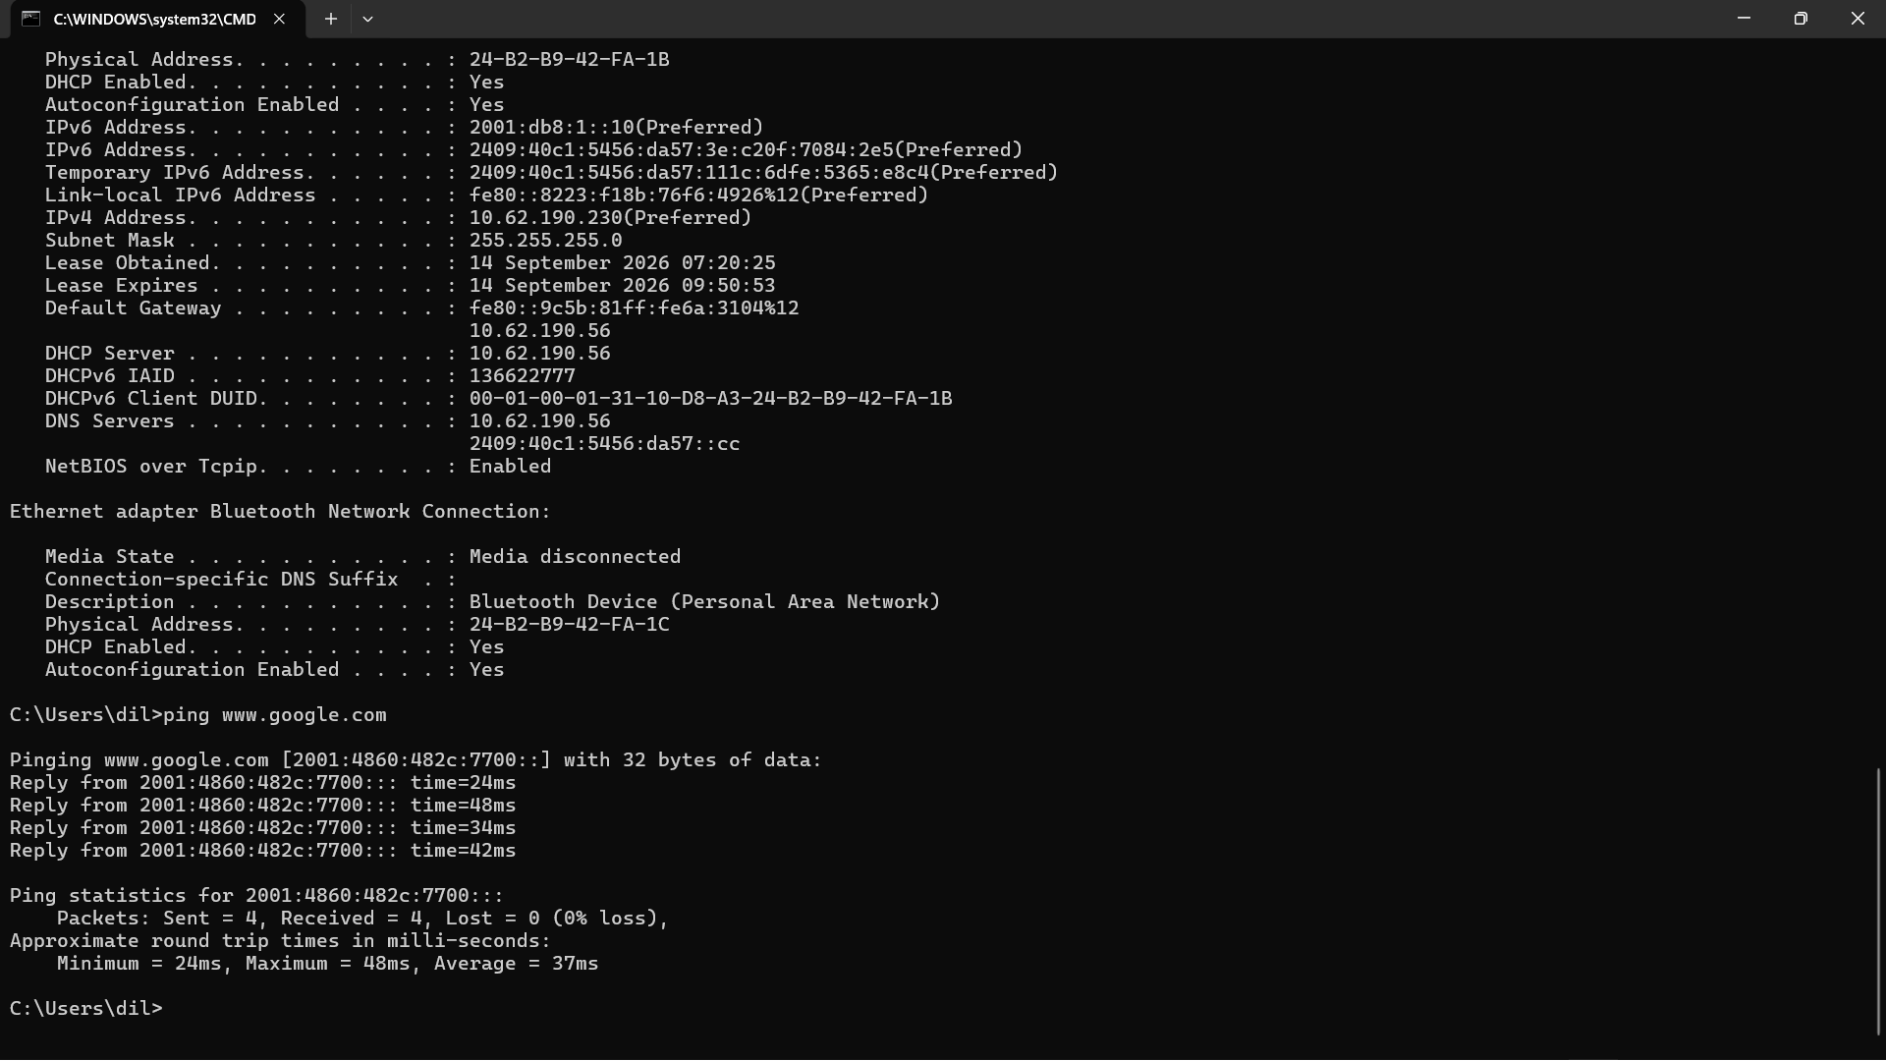

Q3. Trace the Route to Flipkart Using tracert
Steps:
- Open Command Prompt.
- Run the command below.
- Wait for the trace to complete. It may take some time.
- Each numbered line represents a hop/router in the path.
- Count the numbered hops up to the destination and write the result below. Some hops may show * because a router does not reply to the trace.
- Take a screenshot of the output. If the output is long, take more than one screenshot.
tracert www.flipkart.com
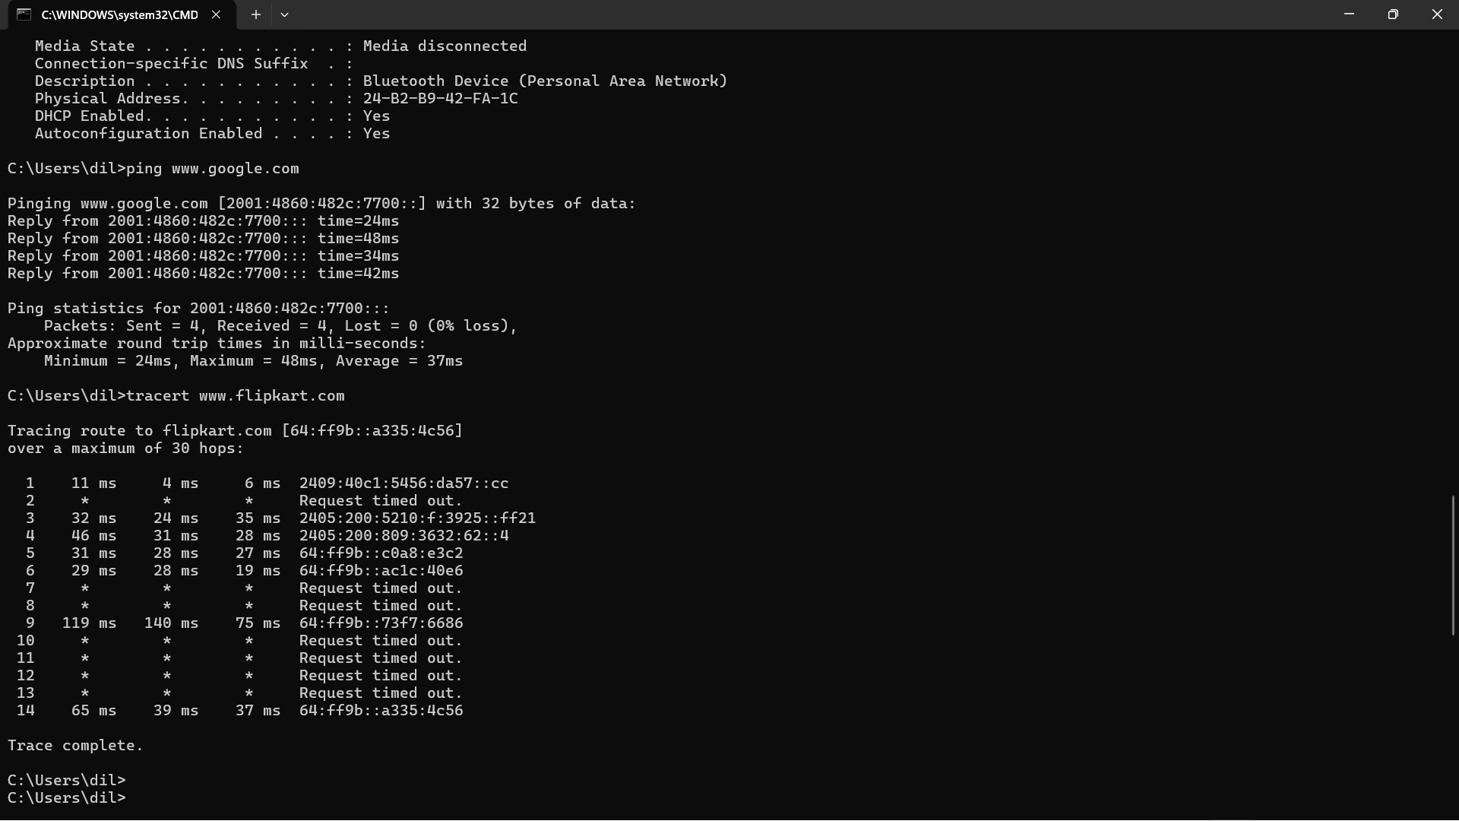
Q4. Find Spotify's IP Address Using nslookup
Steps:
- Open Command Prompt.
- Type the command below and press Enter.
- Look for the returned Address/Addresses in the answer section.
- Write the IP address or addresses shown on your own PC and take a screenshot.
nslookup www.spotify.com
One-line explanation: nslookup helps verify DNS resolution by checking whether a domain name can be resolved to its IP address.
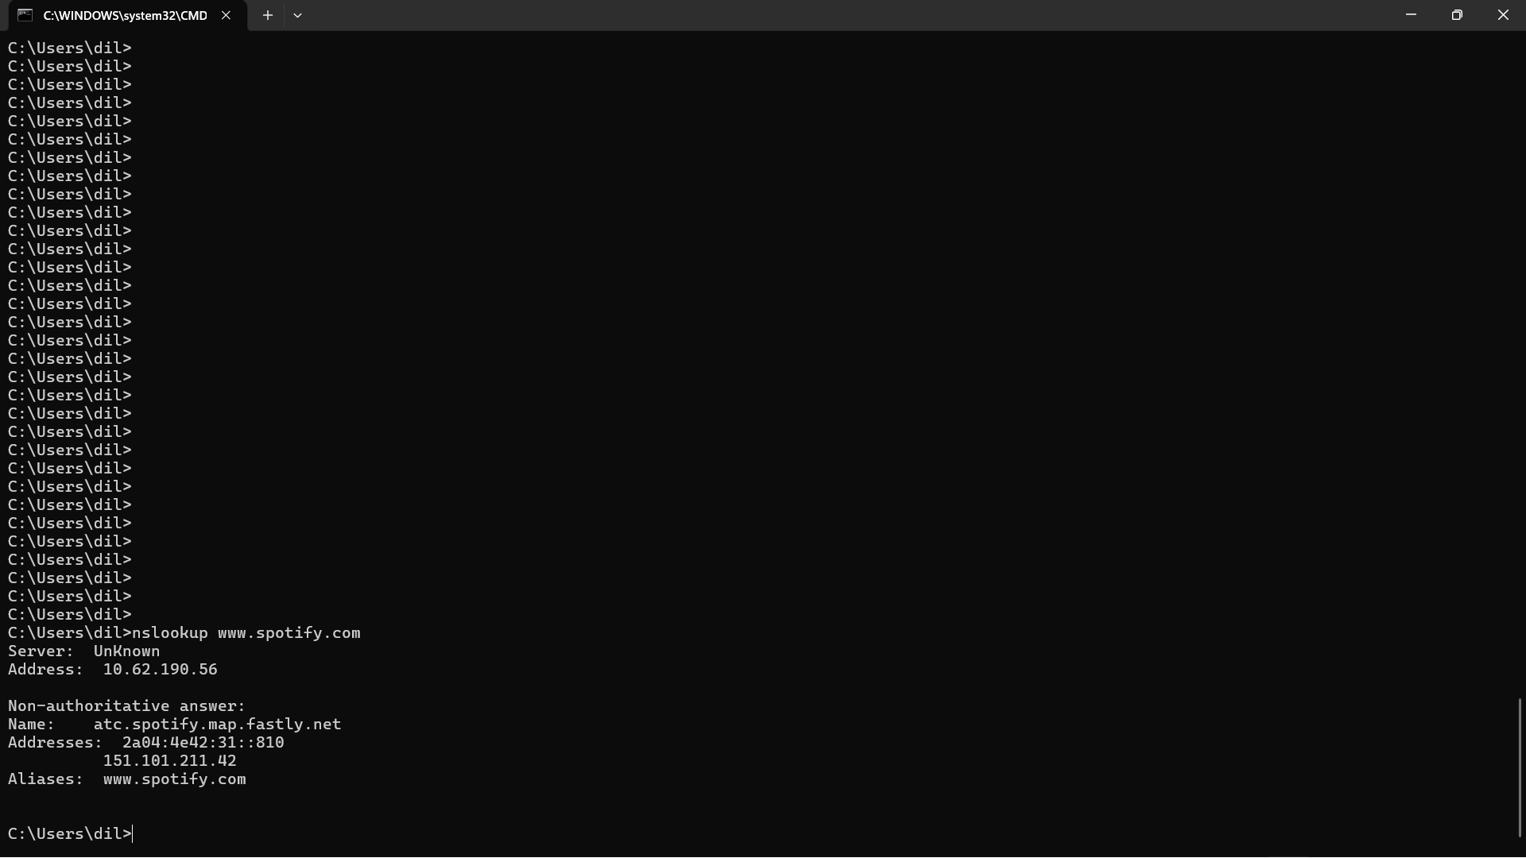

Q5. Three Commands to Troubleshoot Zomato Website Access
If a friend cannot access Zomato's website, I would use the following commands in sequence:
Step | Command | Example | What It Checks
1 | ipconfig | ipconfig | Checks whether the laptop has a valid IPv4 address, subnet information and default gateway.
2 | nslookup | nslookup www.zomato.com | Checks whether DNS can translate Zomato's domain name into an IP address.
3 | ping | ping www.zomato.com | Checks basic reachability and shows whether replies are received. Some websites may block ping, so no reply does not always mean the website is down.
If more diagnosis is required, tracert www.zomato.com can be used to see where the route stops or experiences problems.

Conclusion
The ipconfig, ping, tracert and nslookup commands are useful basic network troubleshooting tools. They help check local IP configuration, connectivity, the route followed by packets, and DNS name resolution.

